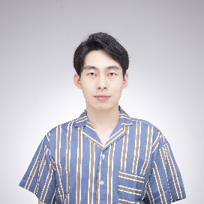

Jinda Li



[neil_jnda@outlook.com](mailto:neil_jnda@outlook.com)

<https://neiljnda.github.io/>





PROFESSIONAL

**Game Designer** *Mar.- Jul. 2021*

24 Entertainment Intern, ***Naraka: Bladepoint***

Participated in the design the melee weapon *dagger*. Organized the animation requirement document to optimize the art asset pipeline.

Optimized the movement experience in complex environments and updating the Level Standard document.

Involved in the early designing of the new battle map. Designed interactive objects with regional features.



PERSONAL EXPERIENCE

*The Near World*

3D pixel-style story-based game, an adventure about self-saving with an AI robot.

*Jormungand*

Puzzle platform game that everything can loop in the space.

4 Game Jam submissions and 4 prototypes

*Last Train*: Board game inspired by *Snowpiercer.*

*Rotator*: Shooting in the different facets of the 2D world. Change your view, and things become different.

Find all my games on <https://neiljnda.github.io/> !

SKILLS

**

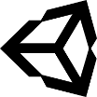Prototyping

Be familiar with Unity development, ready to rapidly create prototypes and verify new mechanism.

C++/C#

Unity

Design and Analysis

Have experience in level design, battle design, narratives. Generate insights from a great number of gaming experience with analytical thinking. Be versatile to meet various works in **teamwork**.

Hardware

Python

Programming

Proficient in C++/C# and glad to work in a team with git or SVN. Familiar with software design patterns and able to write maintainable code. Studied machine learning and ready to use in practice.

Adobe Suite

English & Chinese



EDUCATION HOBBIES



Badminton

Photography/Filming

**Game Design and Production**, Aalto University (Finland)

Master of Science Expected Jul.2023 2021-

**Electrical Engineering**, Southeast University (China)

Bachelor of Engineering 2016-2020